To run our product you need to have Eiffel Studio installed on your computer (available on <https://www.eiffel.com/forms/download-eiffelstudio/>). After opening Eiffel Studio, choose rms.ecf file and make sure that the target of the program is rms_standalone.

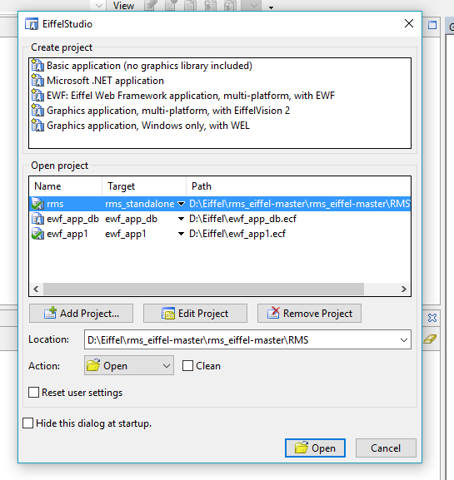

On the right from the code you can see a list of libraries of the project. The sqlite library must be there.

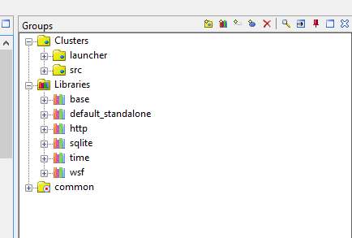

If you cannot find the sqlite library, add it to the project. Click on

Add a library icon on the panel above the folders with code and libraries.

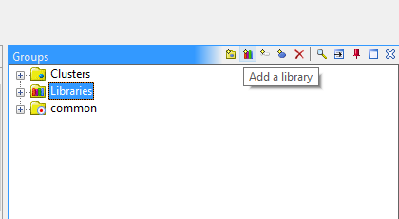

Find and choose sqlite and click on the include button.

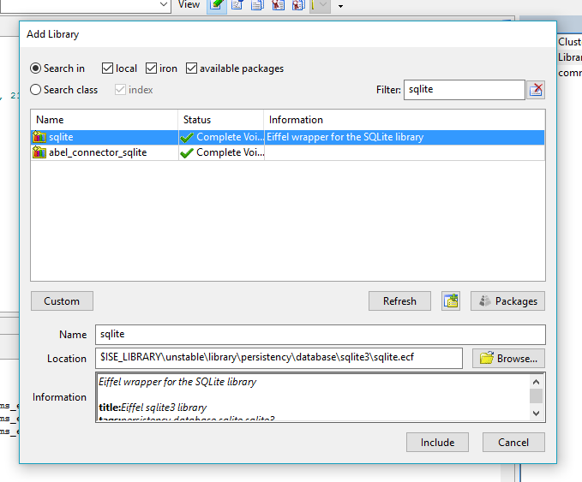

After including necessary libraries,compile and run the project using special buttons.

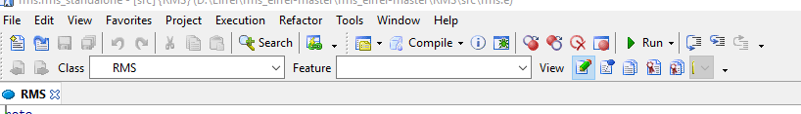

On this step you can test functionality in any browser; but Microsoft Edge and Internet Explorer are preferable. Type <http://localhost:8080> in the address bar and open authorization page.

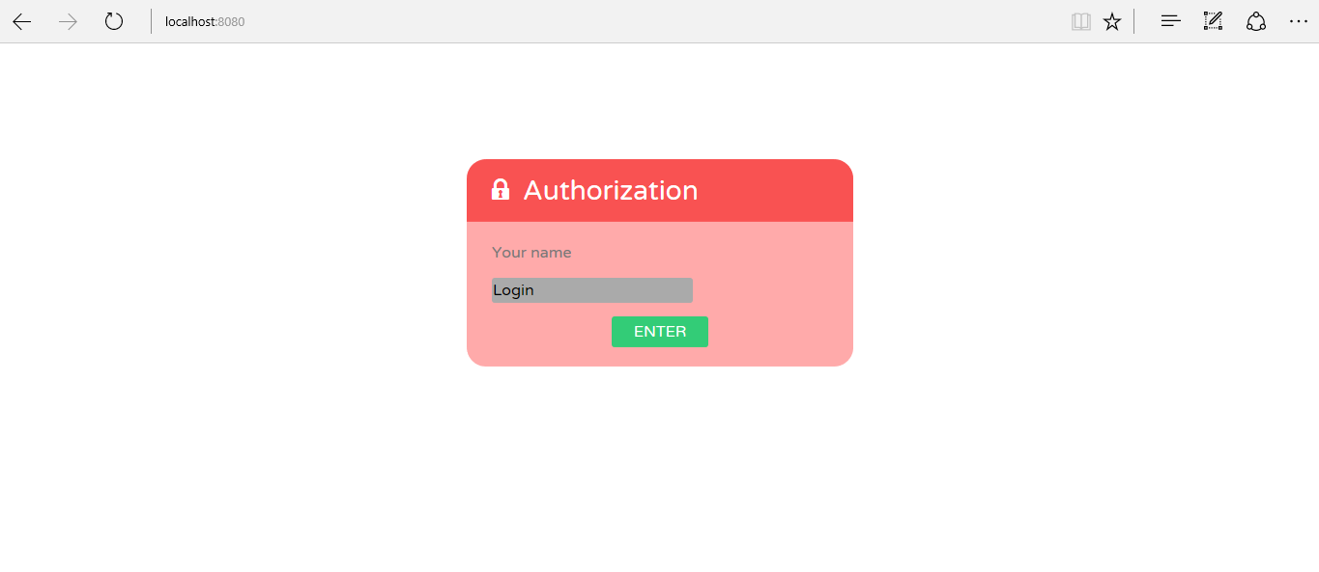

After login you can input a report period on the next page.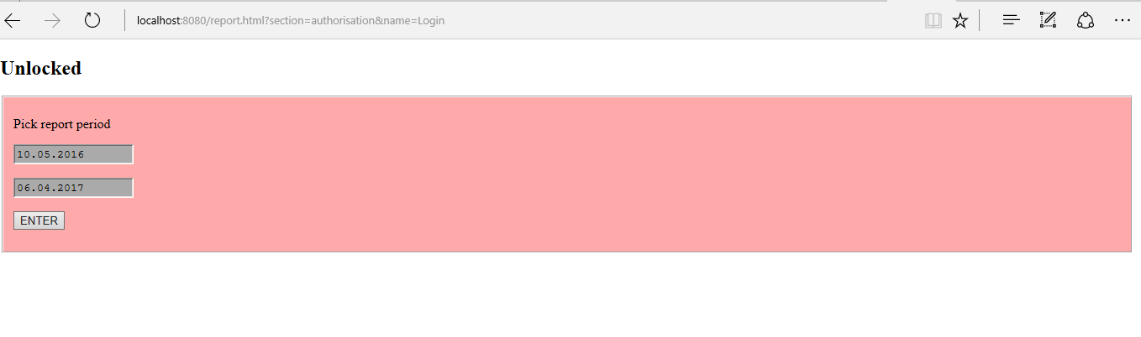

And finally, the page with the choice of the menu item depending on your needs appears.

